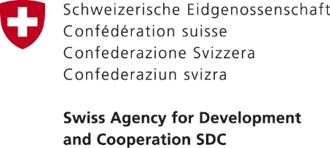 | 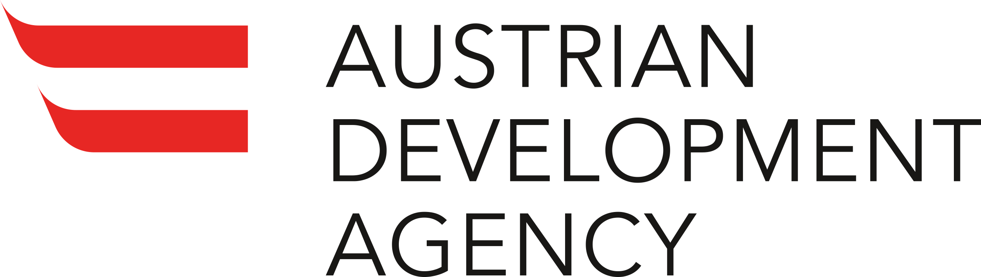 | 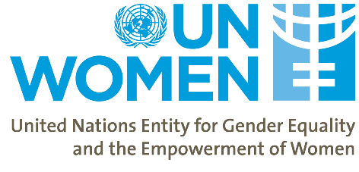
Planning Workshop
Tuesday, January 21 – 23, 2020
Borjomi, Tbilisi

Tuesday 21 January
8:30 – 11:00 | Travel from Tbilisi to Borjomi
11:00 – 11:30 | Coffee Break
11:30 – 12:30 | Opening session (Plenary)  - Opening and overview of the objectives of the meeting by Mehjabeen Alarakhia, Programme Specialist, UN Women  - Participants share their expectations
12:30 – 13:30 | Updates of Project Implementation to date: Armenia and Azerbaijan (Plenary)  Facilitated by Oliva Schmitz, Programme Analyst, UN Women  - UNDP Armenia  - UNDP Azerbaijan
13:30 – 14:30 | Lunch
14:30 – 16:00 | Updates of Project Implementation to date: Grassroots Component Georgia (Plenary)  Facilitated by Oliva Schmitz  - KRDF, TF and CARE  - GFA
16:00 – 16:15 | Coffee break
16:15 – 17:15 | Updates of Project Implementation to date: Policy Components Armenia and Georgia (Plenary)  Facilitated by Nani Bendeliani, Project Analyst, UN Women  - MoESD (GEO)  - MoIDPOTLHSA (GEO)  - ARDA  - Parliament of Georgia  - MLSA (ARM)  - ARMSTAT (ARM)
17:15 – 18:00 | Reflection on 2019 challenges and new opportunities (Plenary)  Facilitated by Mehjabeen Alarakhia, Programme Specialist, UN Women  - Informal discussion
19:00 – 20:00 | Dinner

Wednesday 22 January
9:30 – 10:30 | Learning Session: ILO Conventions and Women’s Economic Empowerment (Plenary)  Facilitated by Mehjabeen Alarakhia, Programme Specialist, UN Women
10:30 – 11:30 | 2020 Planning: Component 1 (Parallel Sessions)  Facilitated by Olivia Schmitz, Programme Analyst, UN Women  - Partner updates on 2020 DIPs and identification of synergies | 2020 Planning: Component 2 and 3 (Parallel Sessions)  Facilitated by Nani Bendeliani, Project Analyst, UN Women  - Partner updates on 2020 DIPs and identification of synergies
11.30 – 11:45 | Coffee break
11:45 – 13:30 | 2020 Planning Continued: Component 1 (Parallel Sessions)  Facilitated by Olivia Schmitz, Programme Analyst, UN Women  - Partner updates on 2020 DIPs and identification of synergies | 2020 Planning Continued: Component 2 and 3 (Parallel Sessions)  Facilitated by Nani Bendeliani, Project Analyst, UN Women  - Partner updates on 2020 DIPs and identification of synergies
13:30 – 14:30 | Lunch
14:30 – 15:45 | 2020 planning: Grassroots work Armenia, Azerbaijan and Georgia (Plenary)  Facilitated by Olivia Schmitz, Programme Analyst, UN Women  - Presentation of regional collaboration activities  - Brief presentations by each partner on plans by quarter of 2020
15:45 – 16:00 | Coffee break
16:00 – 17:30 | 2020 planning: Policy Components work (Plenary)  Facilitated by Nani Bendeliani, Project Analyst, UN Women  - Presentation of regional collaboration activities  - Brief presentations by each partner on plans by quarter of 2020
17:30 – 18:30 | 2020 Planning: What else is needed for upscaling results?  Facilitated by Mehjabeen Alarakhia, Programme Specialist, UN Women  - Small groups critically review the project’s ongoing work vis-à-vis the WEESC targets and objectives  - The groups present the outcomes of their discussions
19:00 – 20:00 | Dinner

Thursday 23 January
9:30 – 10:30 | Learning Session: Leaving No One Behind  Facilitated by Olivia Schmitz, Programme Analyst, UN Women  - Social Mobilization  - VSLA
10:30 – 11:30 | Narrative and Financial Reporting (Plenary)
11:30 – 11:45 | Coffee break
11:45 – 12:45 | Communications and visibility guidelines in the WEESC project (Plenary)  Facilitated by Gvantsa Asatiani, Communications Analyst, UN Women  - Refresher on the UN Women communications and visibility guidelines  - Planning communication needs for 2020  - Division of responsibilities for communications  - Q&A
12:45 – 13:30 | Wrap-up  Facilitated by Mehjabeen Alarakhia, Programme Specialist, UN Women  - Each organization briefly summarizes their next steps/key take-aways
13:30 – 14:30 | Lunch
14:30 | Departure to Tbilisi

